Welcome to the thingSoC® Grovey GPIO
The TSOC_GROVEY_GPIO is a sixteen (16) port I2C I/O Expander, based on the Semtech SX1509 chip, in an Embedded Module format for the new thingSoC, Internet of Things open source hardware standard.
Getting Started :
The TSOC_GROVEY_GPIO provides sixteen (16) I/O ports, with four(4) Grove compatible connectors. You can use the TSOC_GROVEY_GPIO when :
- When you need to use 5.0 Volt level I/O with a 3.3V processor.
- When you need more ports than the 3.3V processor can provide.
- When you need to control the power of your grove peripherals.

The TSOC_GROVEY_GPIO is an open source hardware project from PatternAgents, LLC,
and you are free to download the schematics, layouts, gerbers, BOMs, etc and build your own boards if you wish.
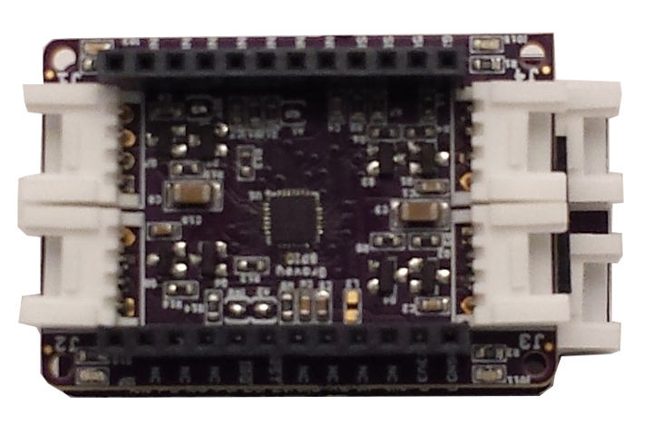

Default Settings :
Default I2C Address : 0x3E
( Remove Jumper A0 to change address to 0X3F)
Semtech SX1509 I/O Assignment :
I/O 00 : J1 Signal X
I/O 01 : J1 Signal Y
I/O 02 : J1 Power Control
I/O 03 : J1 LED (BLUE)
I/O 04 : J2 Signal X
I/O 05 : J2 Signal Y
I/O 06 : J2 Power Control
I/O 07 : J2 LED (RED)
I/O 08 : J3 Signal X
I/O 09 : J3 Signal Y
I/O 10 : J3 Power Control
I/O 11 : J3 LED (GREEN)
I/O 12 : J4 Signal X
I/O 13 : J4 Signal Y
I/O 14 : J4 Power Control
I/O 15 : J4 LED (YELLOW)
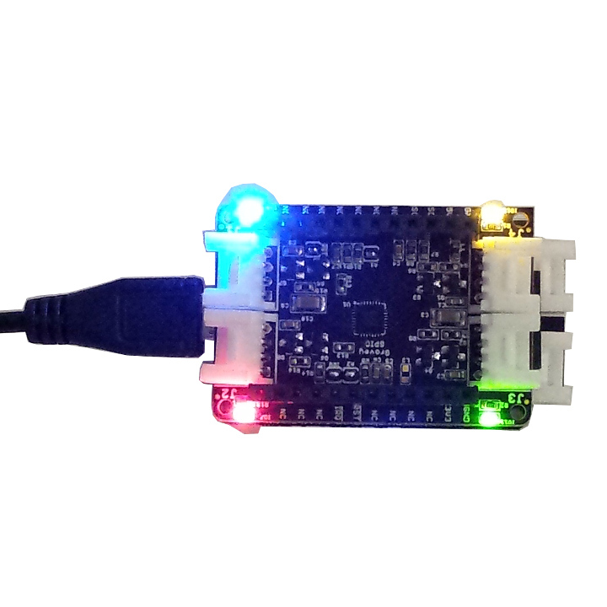

Safe Handling Precautions :
1) Always remove/unplug all power before inserting or removing peripherals.
2) Always ground yourself by touching a ground point before handling your boards.
3) Use a static safe bag when transporting your TSOC_GROVEY_GPIO board.


Adding Grove Peripherals :
The TSOC_GROVEY_GPIO board supports Grove peripherals.
1) Grove connectors are polarized, and can only be plugged in one way.
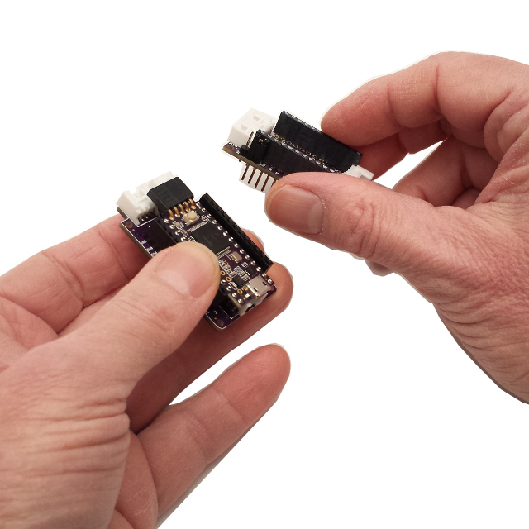

Adding Mikrobus Peripherals :
The TSOC_GROVEY_GPIO board supports Grove peripherals and can interoperate with Mikrobus peripherals.
1) Make sure to align the SQUARE/CUT edges of the Mikrobus board together to insure that
the polarity is correct. Push down evenly to seat the boards in the socket.
2) Note that the "stacking pins" are somewhat longer by design, and there will be some
extra space between the boards when using stacking connectors.
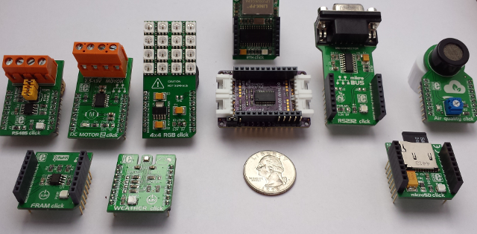
For more information and examples :

Complete documentation, including schematics, layouts, gerbers, and Bill of Materials (BOM) are available on the thingSoC website at :
https://github.com/thingSoC/TSOC_GROVEY_GPIO/tree/master/TSOC_GROVEY_GPIO

There is also a project Wiki available for asking questions and more information at :
https://github.com/thingSoC/TSOC_GROVEY_GPIO/wiki

thingSoC® Grovey GPIO Features :
The TSOC_GROVEY_GPIO is a low cost, embeddable module featuring a Semtech SX1509 device :
- 16 Port I2C GPIO Expander
- 0 Hz to 400KHz I2C Bus Speed
- 3.3 Volt or 5.0 Volt operation
- Optional Active Low Reset Line
- Low Standby current
- Builtin ESD protection
- GPIO (16 Channels)
- Four (4) Color LEDs (Red, Green, Blue, Yellow)
- thingSoC Compliant Module
- Mikrobus Compatible Module
- Support SeeedStudio Grove Peripherals

